SE489 Labs

Course Website: <https://malenezi.github.io/malenezi/SE489/>

YouTube Video: <https://www.youtube.com/watch?v=hQcFE0RD0cQ>

Sample Labs:

Simple Docker Compose: <https://gitlab.com/docker-workshop/Lab-11>

Lab for the DevOps Workshop with Kubernetes and Containers: <https://github.com/stakater/stakater-devops-labs>

Project Ideas (Incremental Assignments)

<https://www.tutorialworks.com/devops-project-ideas/>

This project is a CI pipeline implementation of a webapp on Docker technology with Jenkins: <https://github.com/Sahilkumar098/Mywebserver>

DevOps Exercises

<https://github.com/shayki5/devops-exercises>

# Lab 1: Version Control Systems

## Git

### Definition1:

Git is software for tracking changes in any set of files, usually used for coordinating work among programmers collaboratively developing source code during software development. Its goals include speed, data integrity, and support for distributed, non-linear workflows. – Wikipedia

Definition2:

Git is a DevOps tool used for source code management.

It’s equally interesting to note that *Linus Torvald* himself created git in 2005 for maintaining the code of Linux Kernel.

As opposed to the common perception, git and github are two different entities, following tabulated figure shows major difference between the te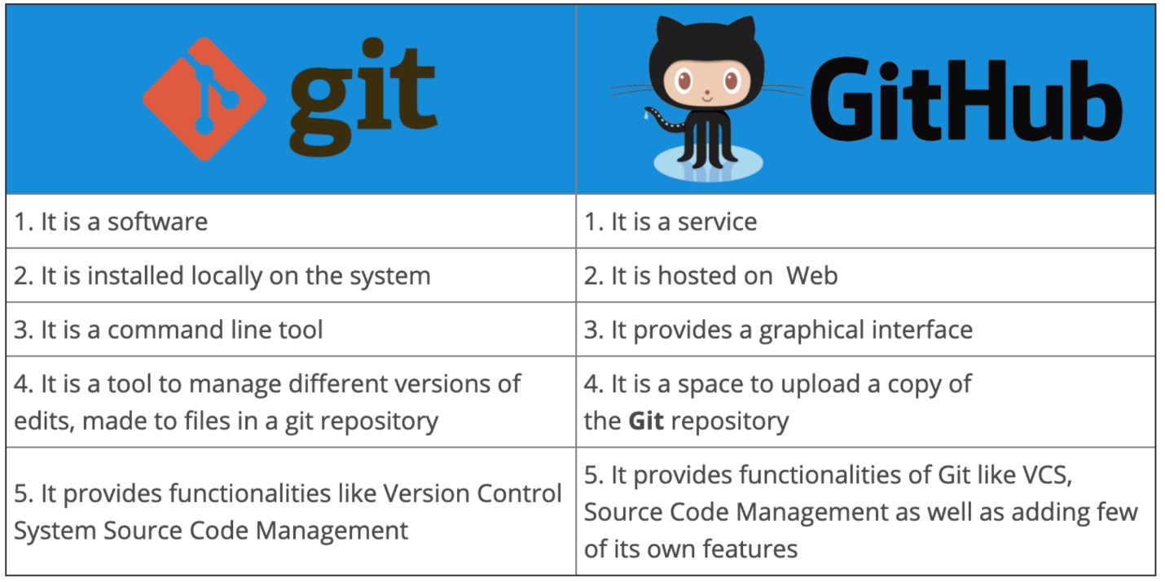

But both of them work in tandem to achive code maintenance, as shown in the following figure-



Before you install git on your system, make sure

1. You have administrative privileges on the system, you want to install git.
2. There is enough space in the hard disk of the system

To install Git at your system, there are few steps which are to be followed

Steps shown below are for windows 11, but they will work on almost all versions of windows with minimal changes

Step1: Download git

Download, latest *standalone* version of the git from its website.

Step 2: Run Installer

Right click on the installer just downloaded and select, Run as Administrator

Click on next

Approve or change the default location

Click on next to accept the default selections or change some additional one, as I have selected additional icons

Select start menu folder

Step 3: Select default text editor

Text editors are programs used for editing text files, by default git shows Vim as default text editor, but it is for linux systems, select Notepad or Notepad++ as per your choice (Notepad++ needs to be installed separately whereas Notepad is supplied with windows)

Step 4: Deciding name of the Initial branch in the repository

By default, it is “master” leave it as it is unless you want to change it

Step 5: Adjusting PATH environments

Step 6: Selecting SSH executable for the git and repository

Step 7: Selecting HTTPS transport backend

Step 8: Configuring the line ending conversions

Step 9: Configuring the terminal emulator

Step 10: Chose the default behavior of ‘git’

Step 11: Choose credential manger

Step 12: Configuring extra options

Step 13: Configuring experimental options

Leave them unchecked, unless you want to use them

Step 14: Click on Install, and let the installation be complete

Step 15: Click finish to complete the setup

This completes the installation of the Git. Git can be started in command line interface as well as in GUI mode, we will explain here, both.

Launching Git in Command Line Interface

Click on Windows start menu and type git bash and press enter, alternatively, you may also click on the icon appearing.

Launching Git in Graphical User Interface

To launch git in GUI, write at Windows Start menu, git gui and press *Enter*, or alternatively, click at git gui icon if shown.

Working with the Local Repositories:

Setting a Local Repository

Local Repositories 🡪 Local working directory/folder

**when git bash is called upon from start menu, it starts at **c:\Users\<username>**, however if you want to create repository at some other location, there is a work around.

Navigate to the folder you want to make local repository with windows explorer, and once at the required location, at the Address bar, write cmd and press Enter, command window will open at the same location. In our case it is *d:\DevApp Tools\Lab Manual.*

When Command Window appears, write **git init** and press *Enter*

Git make current folder, local repository, you will see a folder with .git name appears in the current folder, this means that you have successfully made current folder as local repository in git.

Lab 2: Continuous Integration

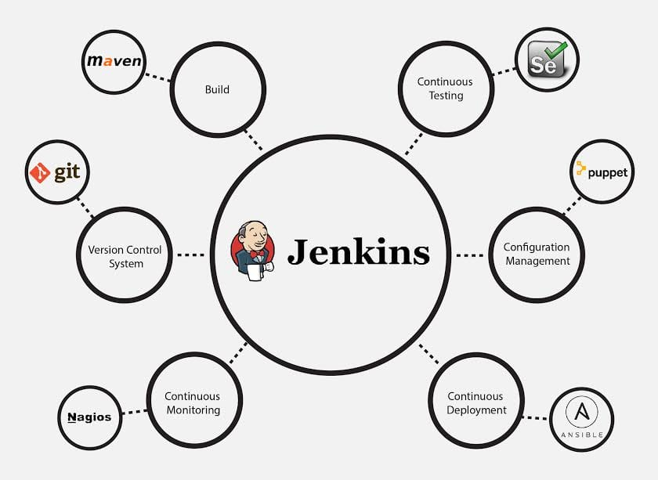

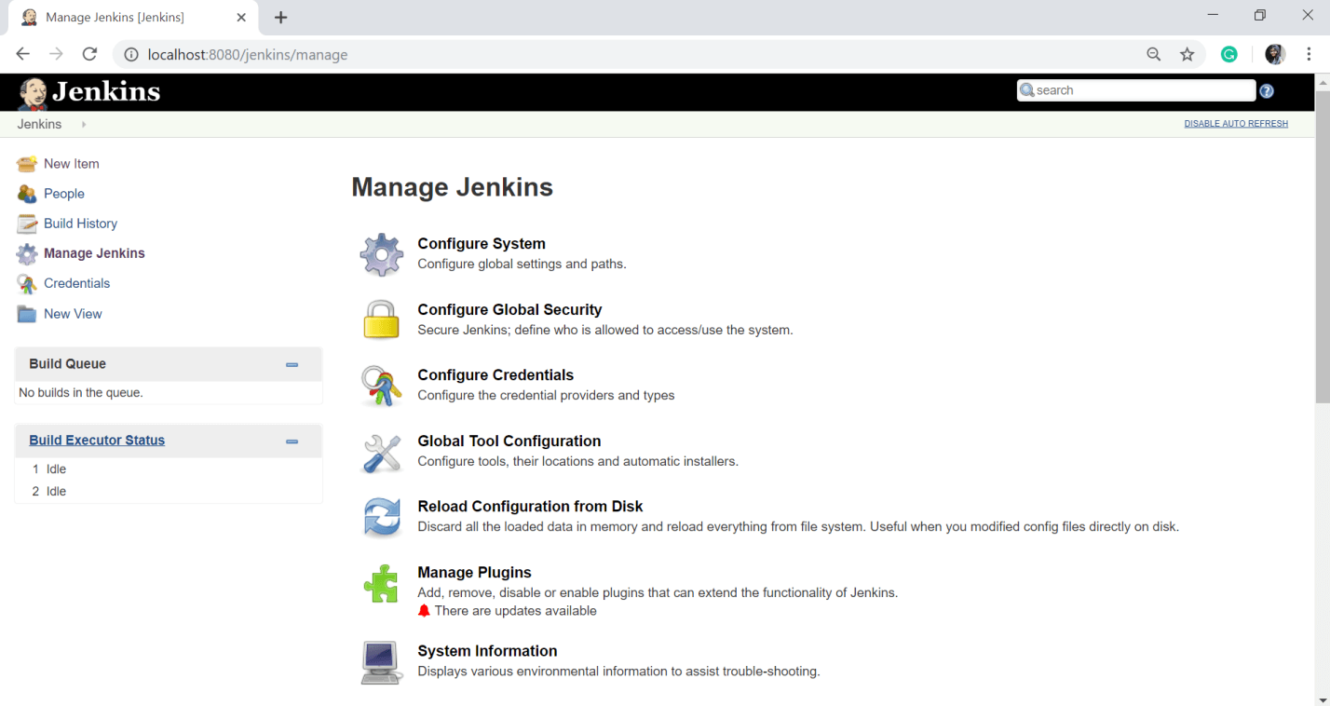

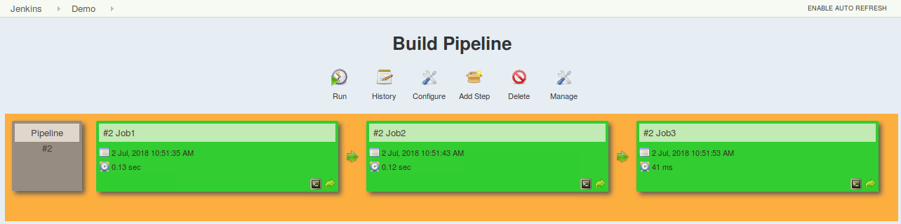

Lab 3: Containerization

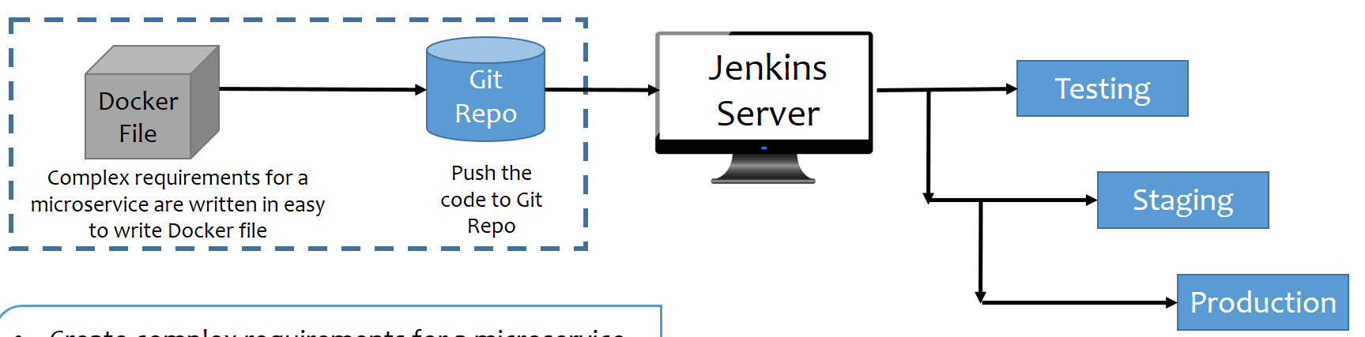

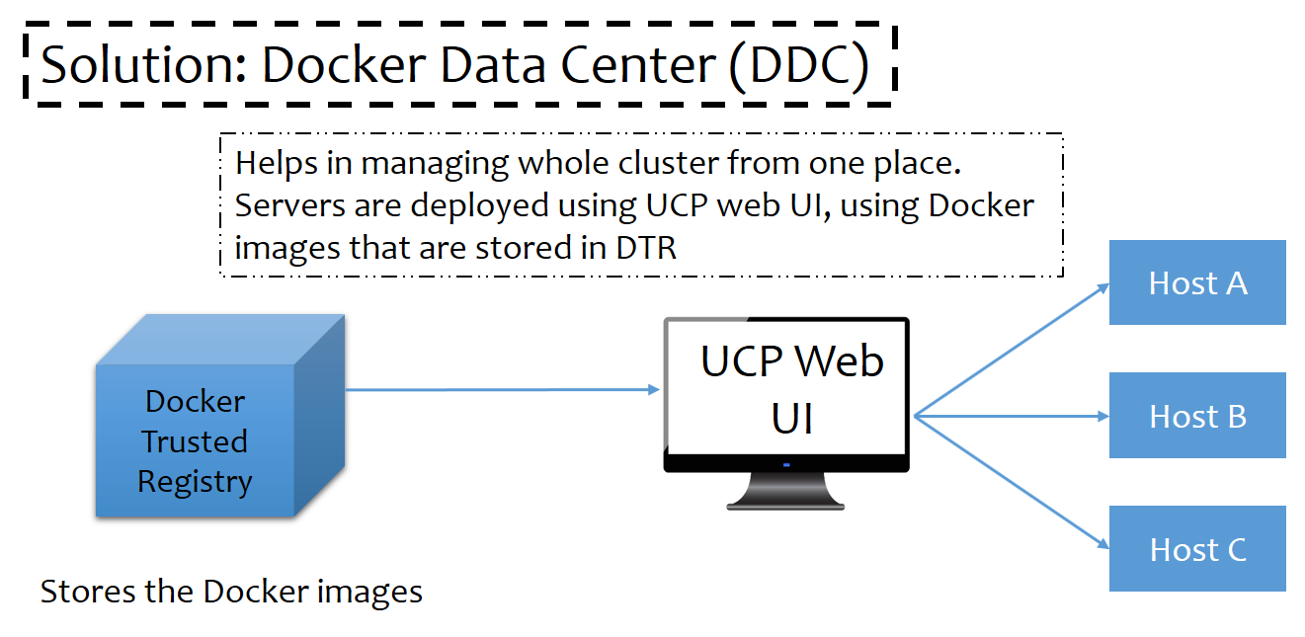

Lab 4: Containers Orchestration

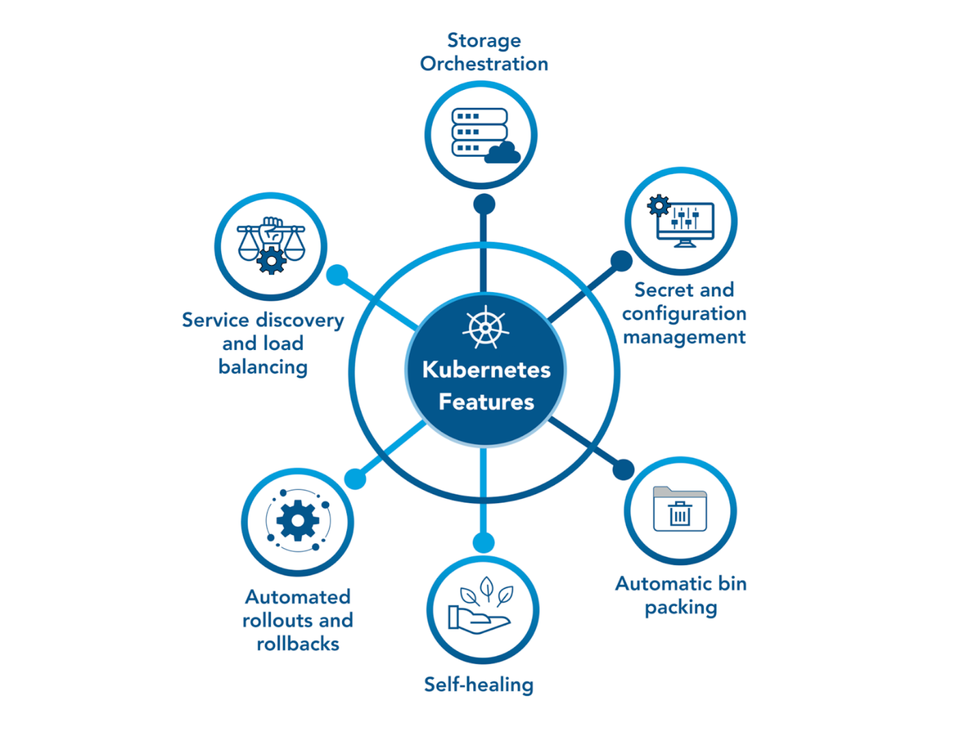

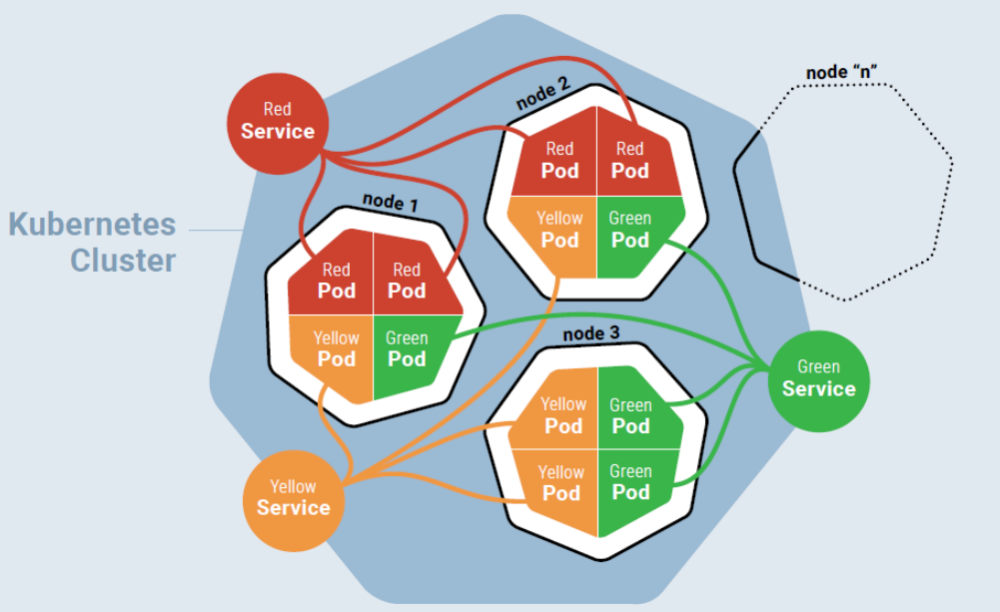

Lab 5: Configuration Management 1

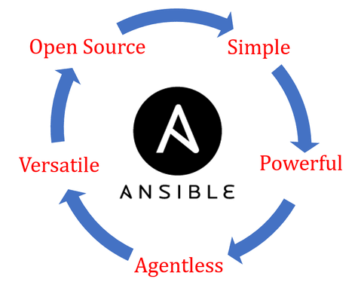

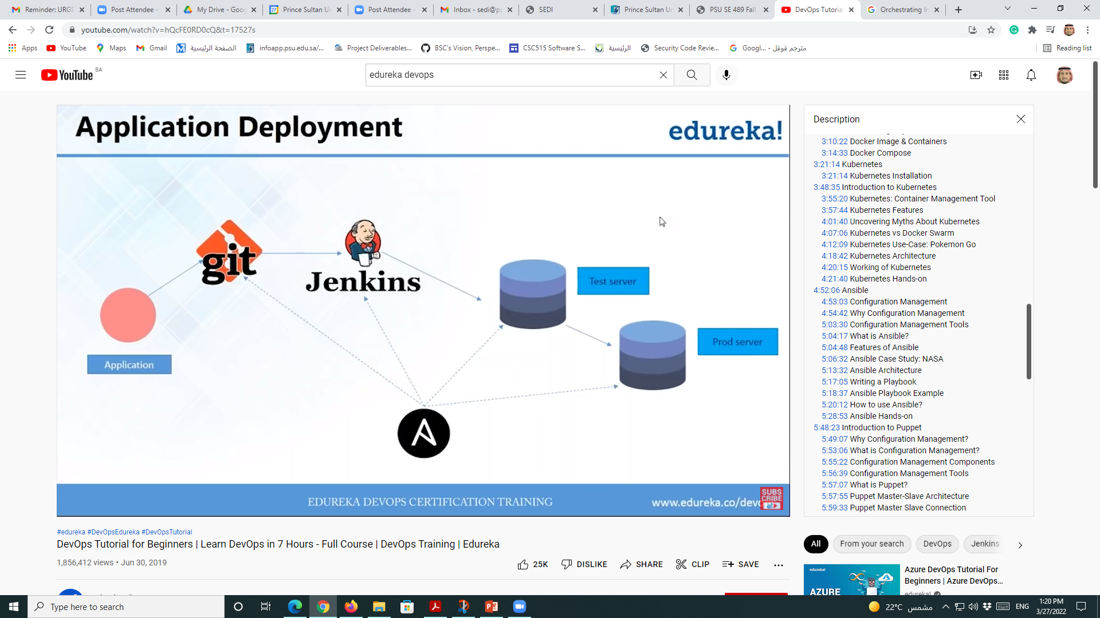

Lab 6: Configuration Management 2

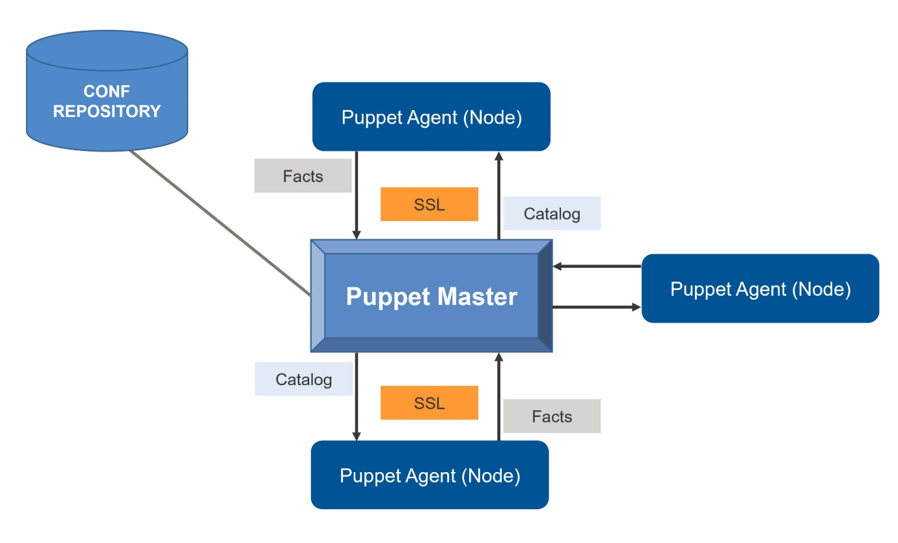

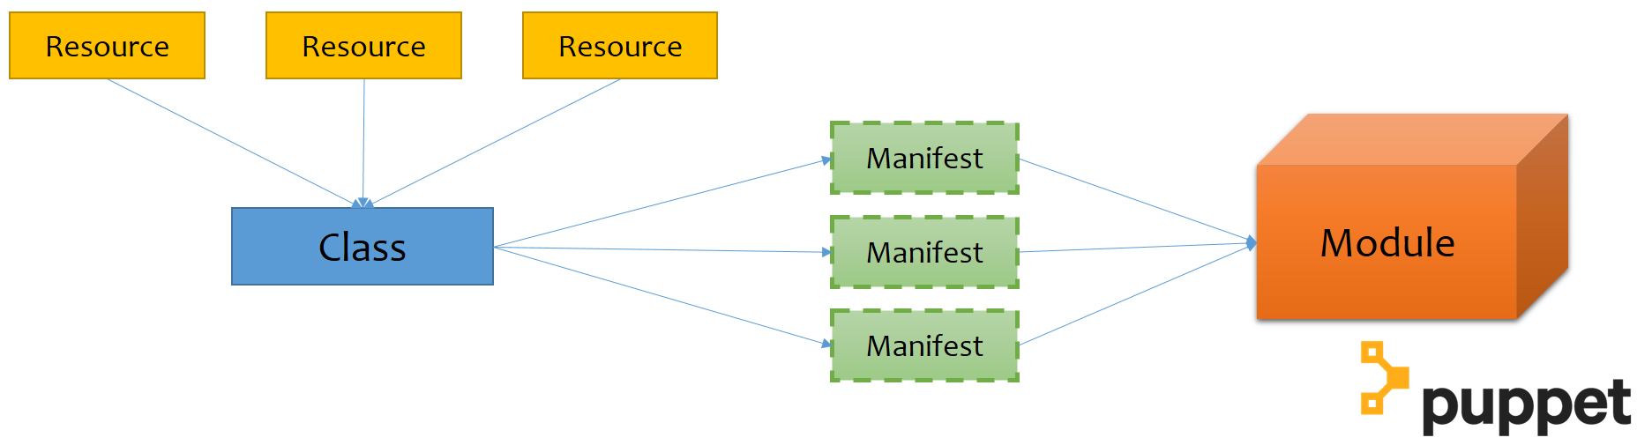

Lab 7: Continuous Monitoring



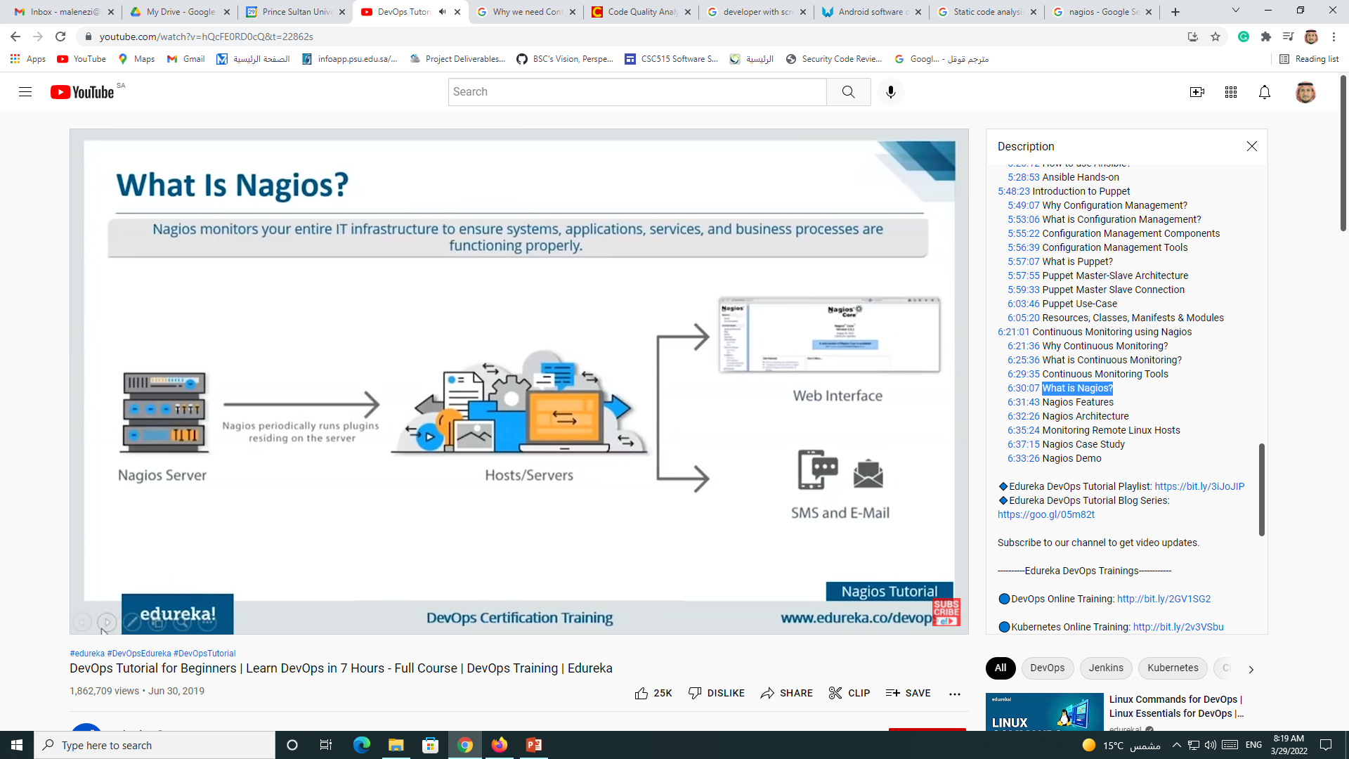

Lab 8: Measuring DevOps

